

**Quantum Simulation**



PROJECT REPORT

BY

**Akash Ramanand Rajak (CSE/435/19008)**

**Amaan Khan (CSE/438/19011)**

**Pallav Dubey (CSE/481/19054)**



*submitted to*

Indian Institute of Information Technology, Kalyani

*final Year Project*

**Bachelor of Technology**

**In**

**Computer Science and Engineering**

May, 2023

***Certificate***

This is to certify that project report entitled “**Quantum Simulation” being submitted by Akash Ramanand Rajak (Reg No. 435), Amaan Khan (Reg No. 438) and Pallav Dubey(Reg No. 481)**, undergraduate students in the Department of Computer Science and Engineering, Indian Institute of Information Technology Kalyani, West Bengal, 741235, India, for the award of Bachelor of Technology in Computer Science and Engineering, is an original research work carried by them under my supervision and guidance.

The project has fulfilled all the requirements as per the regulations of the Indian Institute of Information Technology Kalyani and in my opinion, has reached the standards needed for submission. The work, techniques and the results presented have not been submitted to any other university or institute for the award of any other degree or diploma.

...................................

**(Dr. Anirban Lakshman)**

**Assistant Professor**

Indian Institute of Information Technology Kalyani

Kalyani, W.B.-741235, India.

**i**

***Declaration***

We hereby declare that the work being presented in this project entitled **Quantum Simulation**, submitted to Indian Institute of Information Technology Kalyani in partial fulfilment for the award of the degree of Bachelor of Technology in Computer Science and Engineering during the period from January 2023 to April 2023 under the supervision of Dr. Anirban Lakshman, Department of Computer Science and Engineering, Indian Institute of Information Technology Kalyani, West Bengal - 741235, India, does not contain any classified information.

Name of the Candidates : Akash Ramanand Rajak (Reg No. 435)

Amaan Khan (Reg No. 438)

Pallav Dubey (Reg No. 481)

Institute Name : Indian Institute of Information Technology Kalyani

Date : 08/05/2023

**ii**

***Acknowledgment***

First of all we would like to take this opportunity to thanks our supervisor Dr. Anirban Lakhsman without whose efforts this project would not have been possible. We are grateful to him for guiding us towards the project wherever possible. We are most grateful to Department of Computer Science and Engineering, IIIT Kalyani, India, for providing us this wonderful opportunity to complete our Final year project.

And last but the biggest of all, We want to thank to each of the group members, for always helping keeping a continuous check that project never wandered off the track from our goal.

IIIT Kalyani Akash Ramanand Rajak (Reg No. 435)

Date : 11/11/2022 Amaan Khan (Reg No. 438)

Pallav Dubey (Reg No. 481)

**iii**

***Abstract***

This project aims on the simulation of various Quantum Operations and real life based Quantum Operation using Python Quantum Libraries.

This is very useful in various Quantum related tasks and operations involving quantum computers. The main application of Quantum Simulation is to study and understand quantum systems, which are often too complex to be solved exactly using classical computers. It involves using a quantum computer or a classical computer with quantum simulation algorithms to simulate the behaviour of quantum systems and explore their properties.

**iv**

***List of Acronyms***

**VQE** – Variational Quantum Eigen solver

**QPE** – Quantum Phase Estimation

**QAOA** – Quantum Approximate Optimization Algorithm

**QMC** – Quantum Monte Carlo

**QA** – Quantum Annealing

**QW** – Quantum Walk

**QFT** – Quantum Fourier Transform

**QAE** – Quantum Amplitude Estimation

**QT** – Quantum Teleportation

**QEC** – Quantum Error Correction

**v**

***List of figures***

1. Classical to Quantum Transition . . . . . . . . . . . . . . . . . . . . . . . . . 2
2. UML Model of Quantum Simulation . . . . . . . . . . . . . . . . . . . . . 3
3. Simulating Physics with computers . . . . . . . . . . . . . . . . . . . . . . . 4
4. Quantum Simulation of Hamiltonian Dynamics using Qubitization . . . . . . . . . . . . . . . . . . . . . . . . . . . . . . . . . . . . . . . . . . 5
5. Quantum mechanics with its main characteristics. . . . . . . . . . . 8
6. Quantum Gate . . . . . . . . . . . . . . . . . . . . . . . . . . . . . . . . . . . . . . . 9
7. Quantum Pauli Gates . . . . . . . . . . . . . . . . . . . . . . . . . . . . . . . . . 10
8. Quantum Hadamard Gate . . . . . . . . . . . . . . . . . . . . . . . . . . . . . 15
9. Quantum Controlled Not Gate . . . . . . . . . . . . . . . . . . . . . . . . . 15
10. Quantum Toffoli Gate . . . . . . . . . . . . . . . . . . . . . . . . . . . . 15
11. Quantum SWAP Gate . . . . . . . . . . . . . . . . . . . . . . . . . . . . 15

**vi**

**Content**

**List of Acronyms vi**

**List of Figures vii**

**1.) Introduction 1**

**2.) Fundamentals of Quantum Simulation 7**

2.1) Basic Principles of Quantum Mechanics . . . . . . . . . . . . . . 8

2.2) Quantum gates and quantum circuits. . . . . . . . . . . . . . . . 8

2.3) Approaches to quantum simulation . .. . . . . . . . . . . . . . . . 9

**3.) Quantum Simulations 11**

3.1) Real Life Quantum Simulations . . . . . . . . . . . . . . . . . . . . 12

3.2) Relations and Comparisons . . . . . . . . . . . . . . . . . . . . . . . 13

**4.) Results 14**

**5.) Conclusion, Challenges and Further Scope 16**

**Bibliography 18**

**vii**

**Chapter 1**

**Introduction**

**1**

Quantum simulation is a rapidly growing field at the intersection of quantum physics and computational science. It involves using quantum systems, such as quantum computers, quantum simulators, or other quantum devices, to simulate and study the behaviour of complex quantum systems that are difficult to study using classical computers.

Below is the figure showing the Transition from Classical to Quantum Computer.

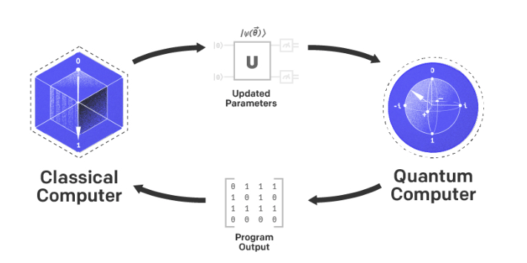

Figure [1] : Classical to Quantum Transition

As a result we simulated some of the quantum programs using different python modules and discussed on the relations and comparisons among those simulations. **2** 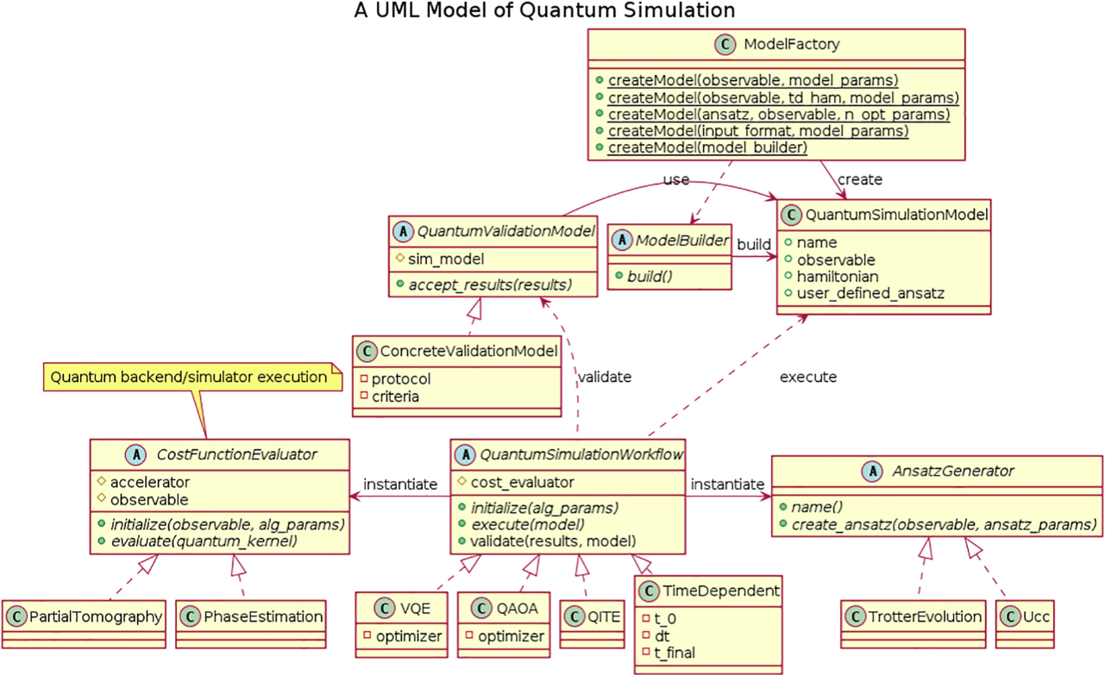

Figure [2] : UML Model of Quantum Simulation

The motivation for this topic 1.) Advancement of Science: Quantum simulation has the potential to revolutionize scientific research by enabling the study of complex quantum systems that are challenging to investigate using classical computers. 2.) Technological Innovation: It has implications for technological advancements, particularly in areas such as quantum computing, quantum communication, quantum sensing, and quantum imaging. 3.) Practical Applications: It has practical applications in areas such as drug discovery, materials design, and optimization of chemical processes. 4.) Interdisciplinary Nature: It is an interdisciplinary field that intersects with multiple disciplines, including physics, chemistry, materials science, computer science, and biology.

**3**

In the past years various experiments and literature were published and some of those are listed below:

In 1982, Richard Feynman published a paper named “Simulating Physics with Computers”. This paper proposed the concept of using quantum computers to simulate the behavior of quantum systems, and is widely regarded as a foundational paper in the field of quantum simulation.

Figure [3] : Simulating Physics with computers

In 2000, A literature paper “"Quantum Simulation of Hamiltonian Dynamics" by E. Farhi, J. Goldstone, S. Gutmann, and M. Sipser” was published that presented an algorithm for simulating the dynamics of a quantum system using a quantum computer.

In 2006, "Quantum simulation of lattice gauge theories using Wilson fermions" a paper was submitted by Martin Müller et al. that talked about a quantum simulation algorithm for simulating lattice gauge theories, which are important models in particle physics.

In 2012, R. Blatt and C. F. Roos published a paper **“**Quantum Simulation of Many-Body Physics with Trapped Ions" that discussed the use of trapped ions for quantum simulation.

**4**

In 2013, A. W. Harrow, A. Hassidim, and S. Lloyd published a paper "Quantum Simulation with Preconditioned Operator Splitting" that presents a quantum simulation algorithm that uses preconditioned operator splitting to simulate the behavior of quantum systems. The authors demonstrate that their algorithm can be used to efficiently simulate a wide range of quantum systems, including those that are difficult to simulate using classical computers.

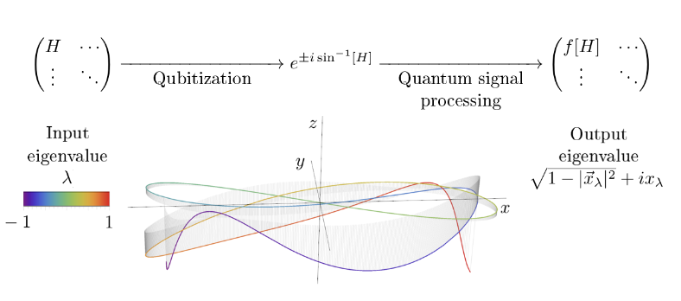

Figure [4] : Quantum Simulation of Hamiltonian Dynamics using Qubitization

And so on…

We did research on various articles based on the Quantum Simulation and simulating programs using digital operations instead of using.

**5**

The structure of the report is as follows:

Chapter 1: It discusses about brief introduction of what the topic is all about, and what’s the motivation of the project and discussed about the literature review that includes the past experiments and research paper that were published in the past years in the context of Quantum Simulations and with less hardware requirements.

Chapter 2: In this chapter we gave the brief about Basic Principles of the Quantum Mechanics, talked little about the quantum gates and its circuits and at the end of chapter discussed about the approaches for Simulation of Quantum processes.

Chapter 3: In chapter 3, we discussed about the simulation of some of the real life quantum simulation programs using different python modules and thereafter compared the results among them.

Chapter 4: In this chapter, we mentioned about the results that we acquired from our simulation programs and processes.

Chapter 5: At last, this chapter deals with a brief conclusion and further scope challenges of this project towards the next generations.

**6**

**Chapter 2**

**Fundamentals of Quantum Simulation**

**7**

**2.1) Basic Principles of Quantum Mechanics**

Quantum mechanics, also known as quantum physics or quantum theory, is a fundamental theory of physics that describes the behavior of particles and systems at the atomic and subatomic scale. It provides a framework for understanding the peculiar and counterintuitive behaviors exhibited by particles such as electrons, photons, and atoms, which cannot be explained by classical physics.

Below are some of the basic and the most common principles:

1. Superposition: Quantum systems can exist in multiple states at once, known as superposition. For example, an electron can exist in a superposition of spin-up and spin-down states simultaneously, until measured.
2. Wave-particle duality: Quantum particles, such as electrons and photons, exhibit both wave-like and particle-like behavior. They can behave as waves with properties like interference and diffraction, as well as particles with definite positions and momenta.
3. Quantum entanglement: Quantum systems can become entangled, meaning the state of one system becomes correlated with the state of another system, even if they are physically separated. This phenomenon has been demonstrated in experiments and has important implications for quantum information processing and quantum computing.

**8**

1. Uncertainty principle: The Heisenberg uncertainty principle states that there are fundamental limits to the precision with which certain pairs of physical properties, such as position and momentum, can be simultaneously known. This principle implies that there are inherent uncertainties in the measurements of quantum systems.
2. Quantum coherence: Quantum coherence refers to the ability of quantum systems to maintain their superposition and entanglement properties over time. Coherence is a key factor in quantum technologies, such as quantum computing and quantum communication, as it determines the stability and reliability of quantum systems.

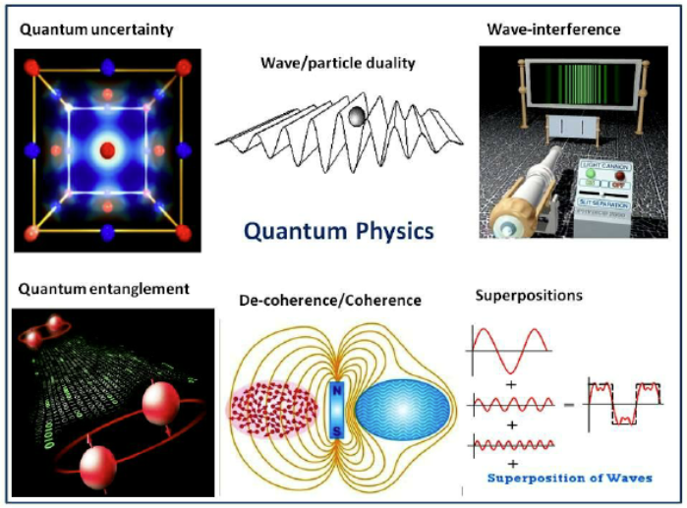

Figure [5] : Quantum mechanics with its main characteristics

**9**

**2.2) Quantum gates and quantum circuits**

Quantum gates are fundamental building blocks of quantum circuits, which are used in quantum computing to manipulate the quantum states of qubits (quantum bits) to perform quantum computations. Quantum gates are analogous to classical logic gates in classical computing, but they operate on the principles of quantum mechanics, which allow for the phenomenon of superposition and entanglement.

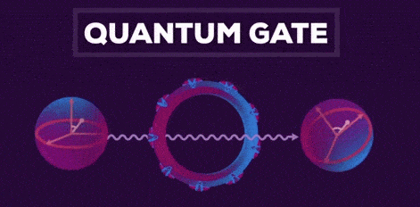

Figure [6] : Quantum Gate

Some commonly used quantum gates are:

1. Pauli gates: Pauli-X, Pauli-Y, and Pauli-Z gates are single-qubit gates that perform rotations around the X, Y, and Z axes of the Bloch sphere, respectively.

Figure [7] : Quantum Pauli Gates

1. Hadamard gate: The Hadamard gate is a single-qubit gate that creates superposition by rotating the qubit from the X-axis to the Y-axis of the Bloch sphere.

Figure [8] : Quantum Hadamard Gate

1. CNOT gate: The CNOT (Controlled-NOT) gate is a two-qubit gate that performs an X-gate on the target qubit conditioned on the state of the control qubit. It is a common entangling gate used in quantum circuits.

Figure [9] : Quantum Controlled Not Gate

1. Toffoli gate: The Toffoli gate is a three-qubit gate that performs a controlled-controlled-not operation. It flips the state of the target qubit if and only if both control qubits are in the state '1'.

Figure [10] : Quantum Toffoli Gate

1. SWAP gate: The SWAP gate is a two-qubit gate that swaps the states of two qubits. It is used for rearranging qubits in a quantum circuit.

Figure [11] : Quantum SWAP Gate

Above we discussed about the most common quantum gates and how their representation in the quantum circuits.

**8**

**2.3) Approaches to quantum simulation**

Quantum simulation is a powerful technique that leverages the principles of quantum mechanics to simulate and study complex quantum systems, such as molecular interactions, material properties, and quantum dynamics.

There are several approaches to quantum simulation, each with its own advantages and limitations. Some of the commonly used approaches to quantum simulation are:

1. Digital quantum simulation
2. Variational quantum simulation
3. Matrix product state (MPS) methods
4. Quantum Monte Carlo methods
5. Analog quantum simulation
6. Quantum tensor networks
7. Quantum walk-based simulation
8. Quantum approximate optimization algorithm (QAOA)
9. Quantum adiabatic simulation
10. Quantum cellular automata

**9**

**Chapter 3**

**Quantum Simulations**

**11**

**3.1) Real Life Quantum Simulations**

As a part of our simulating process, we tried to simulate the following programs using python programming language with the help of various python modules.

We tried to simulate the following programs:

1. Variational Quantum Eigensolver (VQE)
2. Quantum Phase Estimation (QPE)
3. Quantum Approximate Optimization Algorithm (QAOA)
4. Quantum Monte Carlo (QMC)
5. Quantum Annealing
6. Quantum Walk
7. Quantum Fourier Transform (QFT)
8. Quantum Amplitude Estimation (QAE)
9. Quantum Teleportation(QT)
10. Quantum Error Correction (QEC)

**3.2) Relations and Comparisons**

Here in the application and implementation part, the image data that we used were the images captured from the LHC experiment.

And for implementing the Quantum Convolutional Neural Network on that image, we followed the following steps:

* The main component that we considered were the qubits (that can be represented by the state vectors), gates and its operations, and the circuit.
* As a next step, we loaded the dataset and processed it[3].

**12**

* Then we transformed the data in to corresponding circuit[5].
* Then we made the Quantum Convolutional Neural Network Architecture that has the stages namely, manufacturing of Quantum circuits, the construction of Quantum layers, and construction of QCNN Architecture.

At the stage of forming a quantum circuit, three main quantum circuits are needed, namely one cubit unitary circuit*,*two-qubit unitary circuit, and two-qubit pooling circuit

The construction of a quantum layer where there are three layers needed to build a Quantum Convolutional Neural Network Architecture, namely quantum convolution layer*,*quantum pooling layer, and quantum neural network layer.

Finally we visualized the data, trained the model and tested it.

**13**

**Chapter 4**

**Results**

**14**

The accuracy that we got from the CNN method

CNN Accuracy : 73.76 %

The accuracy that we got from QCNN method

QCNN Accuracy : 83.33 %

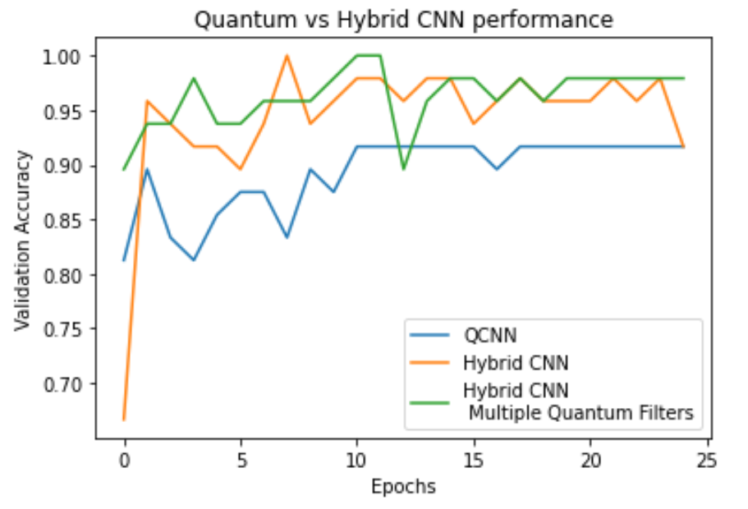

Figure [8] : Quantum Convolutional Neural Network and Convolutional Neural Network Difference

**15**

**Chapter 5**

**Conclusion, Challenges and Further Scope**

**16**

Based on the result of that we concluded from the programs that we simulated above, we can clearly state some of the challenges and future scope for the context of Quantum Simulation for the era of ahead generation.

Following may be the challenges and the future scopes for Quantum Simulation:

* ***Scalability***: One of the main challenges in quantum simulation is scalability. Currently, most quantum simulators are limited to small systems due to the number of qubits and gates available in current quantum hardware. Future directions in quantum simulation include developing techniques that can efficiently simulate larger and more complex quantum systems, and leveraging advancements in quantum hardware, such as fault-tolerant quantum computers and quantum annealers, to enable simulations of systems that are beyond the reach of classical computers.
* ***Error Mitigation and Error Correction***: Quantum hardware is inherently susceptible to errors due to decoherence and other noise sources. Developing effective error mitigation and error correction techniques for quantum simulation is a crucial challenge. This includes developing robust methods for characterizing and mitigating errors, as well as leveraging quantum error correction codes to protect the integrity of quantum simulations. Furthermore, the algorithm of QCNN, can be used for modelling social networks, associative memory devices and automated control systems, etc.
* ***Novel Simulation Techniques***: There is ongoing research in developing new simulation techniques that can leverage the unique properties of quantum systems, such as quantum machine learning, quantum walks, and quantum cellular automata. These novel techniques have the potential to provide new insights and capabilities for quantum simulation.
* ***Validation and Benchmarking***: As quantum simulators become more powerful and sophisticated, it becomes important to develop standards and benchmarks for validating their performance and accuracy. This includes developing standardized protocols for benchmarking quantum simulators, comparing their results against classical simulations or experimental data, and establishing metrics for assessing their performance and reliability.
* ***Accessible Tools and User-friendly Interfaces***: Making quantum simulation tools and platforms more accessible to a wider range of users, including researchers from different disciplines and industries, is an ongoing challenge. Developing user-friendly interfaces, software libraries, and tools for quantum simulation, as well as providing resources for education and training, can help democratize access to quantum simulation capabilities.

**17**

**Bibliography**

[1] Feynman, Richard P. "Simulating physics with computers." Feynman and computation. CRC Press, 2018. 133-153.

[2] Haferkamp, Jonas, et al. "Closing gaps of a quantum advantage with short-time hamiltonian dynamics." Physical Review Letters 125.25 (2020): 250501.

[3] Zache, Torsten Victor, et al. "Quantum simulation of lattice gauge theories using Wilson fermions." Quantum science and technology 3.3 (2018): 034010.

[4] Blatt, Rainer, and Christian F. Roos. "Quantum simulations with trapped ions." Nature Physics 8.4 (2012): 277-284.

[5] Yuan, X., Endo, S., Zhao, Q., Li, Y. and Benjamin, S.C., 2019. Theory of variational quantum simulation. Quantum, 3, p.191.

[6] Pavlidis, A. and Floratos, E., 2021. Quantum-Fourier-transform-based quantum arithmetic with qudits. Physical Review A, 103(3), p.032417.

[7] Bravyi, S. and Vargo, A., 2013. Simulation of rare events in quantum error correction. Physical Review A, 88(6), p.062308.

[8] Hassija, Vikas, et al. "Forthcoming applications of quantum computing: Peeking into the future." IET Quantum Communication 1.2 (2020): 35-41.

**18**